List of ICD Codes

Psychiatric diagnoses in childhood
- ICD-10 codes: F80-F98
- ICD-8 codes: 2958, 299, 3000, 3003, 3013, 3051, 3055, 3056, 3060, 3061, 3062, 3063, 3065, 3066, 3067, 3069, 307, 308, 310, 315, 3479, 7804, 7815, 7816, 7889, 7960

Neurological diagnoses in childhood
- ICD-10 codes: C70-C72, C751, C753, D32-D33, D352, D354, G00-G47, G80-G93, S02, S06, S07, S08
- ICD-8 codes: 0360, 0459, 065, 136, 191, 1920, 1921, 1922, 1923, 1929, 1943, 1944, 1991, 2250, 2251, 2252, 2253, 2254, 2259, 2262, 2263, 2530, 2532, 2580, 2750, 2901, 292, 2932, 2934, 2939, 2941, 2948, 2949, 3008, 3031, 3032, 3039, 3051, 3052, 3053, 3055, 3056, 3059, 3062, 3064, 3068, 3069, 3074, 308, 309, 3200, 3201, 3208, 3209, 321, 322, 323, 324, 3301, 3309, 3310, 3311, 3312, 3319, 3320, 3321, 3329, 3331, 3339, 340, 341, 342, 343, 344, 3448, 3450, 3451, 3452, 3453, 3459, 346, 347, 3470, 3479, 3480, 3481, 3482, 3488, 3489, 3499, 350, 351, 354, 355, 356, 357, 358, 373, 3770, 3789, 3929, 431, 432, 433, 435, 436, 4369, 437, 4389, 447, 4580, 4829, 573, 596, 7149, 7172, 7289, 729, 7339, 738, 7438, 7439, 7803, 7804, 7805, 7806, 7816, 7817, 7832, 7871, 791, 794, 7960, 800, 801, 8020, 8021, 8022, 8023, 8024, 8025, 803, 804, 8500, 8510, 8511, 8520, 8521, 8530, 8531, 8540, 8541, 8720, 8721, 8730, 8731, 8732, 8733, 8737, 8738, 920, 9673, 9679, 9760, 9909, 9953, 9970, 9989, 9991, 9999

Perinatal diagnoses and congenital deformities
- ICD-10 codes: P00-P61, P90-P96, Q00-Q07, Q20-Q28, Q85-Q89
- ICD-8 codes: 0039, 011, 0122, 0270, 0389, 0399, 043, 054, 056, 070, 0780, 0795, 0849, 0909, 112, 1301, 136, 208, 2119, 216, 224, 228, 2699, 280, 2871, 288, 2894, 2899, 3302, 344, 3479, 3489, 350, 356, 357, 360, 368, 425, 470, 486, 5112, 5511, 599, 6110, 6259, 6266, 6269, 6821, 6861, 6869, 703, 7330, 7331, 740, 7410, 7419, 742, 7430, 7431, 7432, 7433, 7434, 7438, 7439, 7442, 7459, 7460, 7461, 7462, 7363, 7464, 7465, 7466, 7468, 7469, 7470, 7471, 7472, 7473, 7474, 7475, 7476, 7478, 7479, 7520, 7527, 7533, 7555, 7560, 7568, 7569, 7572, 7579, 7580, 7581, 7582, 7583, 7588, 7589, 7590, 7591, 7592, 7593, 7594, 7595, 7596, 7598, 7599, 7600, 7601, 7602, 7603, 7604, 7605, 7607, 7610, 7612, 7613, 7614, 7615, 7616, 7617, 7619, 7620, 7621, 7622, 7623, 7624, 7625, 7629, 7630, 7631, 7639, 764, 765, 766, 767, 768, 7690, 7691, 7692, 7693, 7694, 7695, 7699, 7700, 7701, 7702, 7708, 7709, 7710, 7711, 7719, 7720, 7721, 7722, 7729, 773, 7740, 7741, 7742, 7749, 7750, 7751, 7752, 7759, 7760, 7761, 7762, 7763, 7764, 7769, 777, 7780, 7781, 7782, 7789, 7790, 7799, 7802, 7824, 7841, 7901, 9602, 9990, 9998
Supplementary Table 1. Associations of IQ score with educational and occupational achievement.
 | Cohort |  |  |  | Within sibship
 | b (SE) | p value |  |  |  | b (SE) |  |  | p value
Unadjusted associations
GPA in lower secondary school (N=93,458 → 44,677 sibships)
IQ | 0.128 (0.001) |  |  |  |  | 0.093 (0.001)
IQ² | -3.55x10⁻⁵ (1.99x10⁻⁵) |  |  |  |  | -8.82x10⁻⁵ (2.73x10⁻⁵)
IQ³ | -1.87x10⁻⁵ (8.13x10⁻⁷) | <0.001 |  |  |  | -1.54x10⁻⁵ (9.71x10⁻⁷) |  | <0.001
Social benefits at ages 18-30 (N=108,855 → 52,211 sibships)
IQ | -0.027 (0.001) |  |  |  |  | -0.014 (0.001) |  | <0.001
IQ² | 1.42x10⁻⁴ (3.04x10⁻⁵) | <0.001 |  |  |  | -
Log of gross income at age 30 (N=228,817 → 108,552 sibships)
IQ | 0.003 (1.67x10⁻⁴) |  |  |  |  | 0.003 (2.74x10⁻⁴)
IQ² | -8.64x10⁻⁵ (9.54x10⁻⁶) | <0.001 |  |  |  | -5.56x10⁻⁵ (1.27x10⁻⁵) |  | <0.001
Adjusted associations*
GPA in lower secondary school (N=93,458 → 44,677 sibships)
IQ | 0.118 (0.001) |  |  |  |  | 0.094 (0.001)
IQ² | -4.58x10⁻⁵ (1.95x10⁻⁵) |  |  |  |  | -8.05x10⁻⁵ (2.72x10⁻⁵)
IQ³ | -1.78x10⁻⁵ (7.90x10⁻⁷) | <0.001 |  |  |  | -1.58x10⁻⁵ (9.69x10⁻⁷) |  | <0.001
Social benefits at ages 18-30 (N=108,855 → 52,211 sibships)
IQ | -0.017 (0.001) |  |  |  |  | -0.011 (0.001) |  | <0.001
IQ² | 1.00x10⁻⁴ (3.13x10⁻⁵) | 0.001 |  |  |  | -
Log of gross income at age 30 (N=228,817 → 108,552 sibships)
IQ | 0.002 (1.97x10⁻⁴) |  |  |  |  | 0.002 (3.18x10⁻⁴)
IQ² | -3.63x10⁻⁵ (1.08x10⁻⁵) | 0.001 |  |  |  | -4.23x10⁻⁵ (1.30x10⁻⁵) |  | 0.001
*Adjusted for year of birth, ethnicity, birth region, parental education at birth, out-of-home care in childhood, psychiatric diagnoses in childhood, neurological diagnoses in childhood, and perinatal diagnoses and congenital deformities.
IQ indicates a linear IQ term, IQ² indicates a quadratic IQ term, and IQ³ indicates a cubic IQ term.
Missing values have been imputed by use of multiple imputation.

Supplementary Figures 1-3
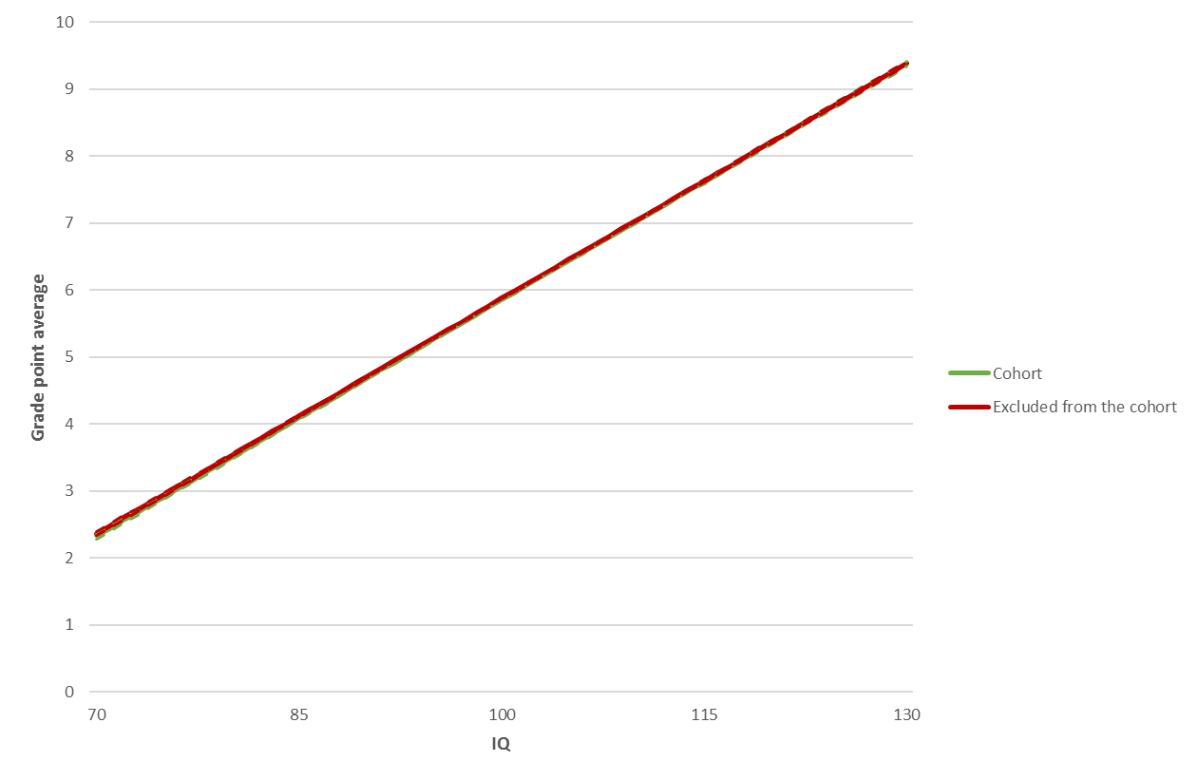
Supplementary Figure 1. Grade point average according to IQ.
Association is adjusted for year of birth, ethnicity, birth region, parental education at birth, out-of-home care in childhood, psychiatric diagnoses in childhood, neurological diagnoses in childhood, and perinatal diagnoses and congenital deformities.

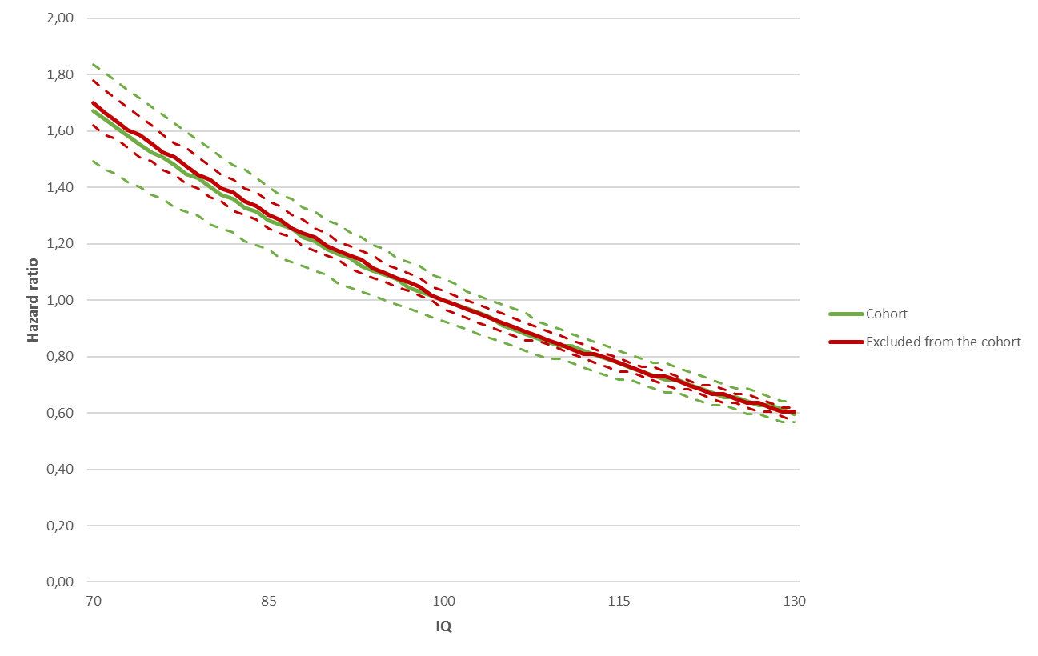
Supplementary Figure 2. Hazard ratio for social benefits according to IQ.
Association is adjusted for year of birth, ethnicity, birth region, parental education at birth, out-of-home care in childhood, psychiatric diagnoses in childhood, neurological diagnoses in childhood, and perinatal diagnoses and congenital deformities.

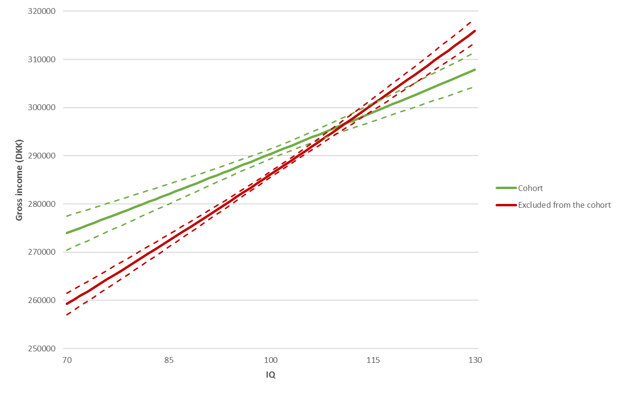
Supplementary Figure 3. Gross income according to IQ.
Association is adjusted for year of birth, ethnicity, birth region, parental education at birth, out-of-home care in childhood, psychiatric diagnoses in childhood, neurological diagnoses in childhood, and perinatal diagnoses and congenital deformities.

Supplementary Table 2. Associations of IQ score with educational and occupational achievement.
 | Cohort |  |  |  | Excluded individuals
 | b (SE) | p value |  |  |  | b (SE) |  |  | p value
GPA in lower secondary school (N=93,458/N=207,090)
IQ | 0.118 (0.001) |  |  |  |  | 0.117 (4.81x10⁻⁴)
IQ² | -4.58x10⁻⁵ (1.95x10⁻⁵) |  |  |  |  | -7.07x10⁻⁵ (1.34x10⁻⁵)
IQ³ | -1.78x10⁻⁵ (7.90x10⁻⁷) | <0.001 |  |  |  | -1.77x10⁻⁵ (6.16x10⁻⁷) |  | <0.001
Social benefits at ages 18-30 (N=108,855/N=251,381)
IQ | -0.017 (0.001) |  |  |  |  | -0.017 (4.37x10⁻⁴)
IQ² | 1.00x10⁻⁴ (3.13x10⁻⁵) | 0.001 |  |  |  | 4.95x10⁻⁵ (2.16x10⁻⁵) |  | 0.02
Log of gross income at age 30 (N=228,817/N=571,596)
IQ | 0.002 (1.97x10⁻⁴) |  |  |  |  | 0.003 (1.34x10⁻⁴)
IQ² | -3.63x10⁻⁵ (1.08x10⁻⁵) | 0.001 |  |  |  | -3.52x10⁻⁵ (5.83x10⁻⁶) |  | <0.001
Associations are adjusted for year of birth, ethnicity, birth region, parental education at birth, out-of-home care in childhood, psychiatric diagnoses in childhood, neurological diagnoses in childhood, and perinatal diagnoses and congenital deformities.
IQ indicates a linear IQ term, IQ² indicates a quadratic IQ term, and IQ³ indicates a cubic IQ term.
Missing values have been imputed by use of multiple imputation.

