Supplemental Material

Table S1. Online survey “A community science approach to understanding kitten behaviour” hosted on Qualtrics survey platform completed by kitten foster parent participants (n=72).

- Welcome and Consent

- Foster parent demographics and Ten-item personality index (TIPI)
Previous kitten experience
- How many years have you been fostering kittens?
(Choose one selection from dropdown list: Less than 1 year to 20+ years)
- On average, how many litters of kittens do you foster in one year? (If you’ve fostered for over 5 years, please use the yearly average from the past 5 years)
(Choose one selection from dropdown list: Less than 1 year to 20+ years)
- How would you rate your experience level as a kitten foster parent?
(Choose one selection from: Beginner, Experienced, Expert)
- Aside from being a foster parent, do you currently or have you ever held any of the following positions related to cat and/or animal behaviour? Please select all that apply. (Choose from: None; Cat or Dog Trainer or Behaviour Consultant; Veterinarian; Veterinary Technician, Assistant, Nurse, or Student (or other position within a veterinary clinic setting); Shelter Worker or Volunteer (or other position within a shelter setting); Groomer; Animal Behaviour/Welfare Researcher or Student; Other, please describe [text box])

Foster Demographics
- What is your age in years?
(Choose one selection from dropdown list: 18 to 100+ years)
- What is your gender identity?
(Choose one selection from: Man; Woman; Non-binary; Prefer to self-describe [text box]; Prefer not to answer
- What country do you currently live in?
(Choose one selection from All countries available)
- What type of community do you live in?
(Choose one selection from: Small community (fewer than 29,999 people); Mid-sized community (30,000 to 999,999); Large community (more than 1 million people))
- How many adults (18+ years of age) live in your household (including yourself)?
(Choose one selection from dropdown list: 1 to 10+)
- How many children and/or teenagers (under 18 years of age) live in your household?
(Choose one selection from dropdown list: 1 to 10+)
- Aside from foster kittens, do you have other pets that live in your home? Please select all that apply.
(Choose from: No other pets; Cats; Dogs; Rabbits; Small mammals (e.g., hamsters, guinea pigs, mice, rats); Reptiles/amphibians (e.g., frogs, turtles, snakes); Birds; Fish; Other, please describe [text box])
(If “No other pets” is selected, skip next question)
- How do your foster kittens interact with your own pets? Please select all that apply.
(Choose from: Free interacting or play (i.e., unsupervised); Controlled, supervised interacting or play only; Feeding in the same room; Visual access only (i.e., separated by a barrier but still within visible range); They do not interact; Other, please describe [text box])

Ten-item personality inventory (TIPI)
Here are a number of personality traits that may or may not apply to you. Please select the rating next to each statement to indicate the extent to which you agree or disagree with that statement. You should rate the extent to which the pair of traits applies to you, even if one characteristic applies more strongly than the other. Please select your agreement with each pair of traits
PERSONALITY TRAITS | Disagree strongly | Disagree moderately | Disagree a little | Neither agree nor disagree | Agree a little | Agree moderately | Agree strongly
Extraverted, enthusiastic
Critical, quarrelsome
Dependable, self-disciplined
Anxious, easily upset
Open to new experiences, complex
Reserved, quiet
Sympathetic, warm
Disorganized, careless
Calm, emotionally stable
Conventional, uncreative

- Current kitten information

- How many kittens (between 7 and 9 weeks of age) are you currently fostering?
Note: If more than 10 kittens, please only continue this survey with your 10 oldest kittens within this age range.
(Choose one selection from dropdown list: 1 to 10)
- What are the names of your current foster kittens?
Note: These names will be saved and used throughout the remainder of the survey to answer questions about each individual kitten.
[Text boxes for up to 10 kitten names]
- How many litters make up your current group of kittens? (E.g., if you have 3 kittens from one mother and 1 kitten from a different mother, please put 2 litters)
(Choose one selection from dropdown list: 1 to 10)
- Please specify additional information about the composition of litters if needed.
[Text box]
- At any point, was a nursing mother cat providing some level of care to the kittens currently with you in foster care?
(Choose one selection from dropdown list: Yes, with nursing mother throughout care; No, bottle-fed exclusively throughout care; Inconsistent (partial time with mother, not exclusive); Kittens arrived already weaned, with mother previously; Kittens arrived already weaned, but no mother and only bottle fed previously; Kittens arrived already weaned, unknown history of mother; Unknown)
- Were any of your kittens sick or injured when they came into your care?
(Choose one selection from Yes/No) [If Yes, next question prompted]
- Please explain which kittens were sick or injured, what the diagnosis was, and how kittens were treated.
[Text box]

- Current kitten experiences and behaviours
Note: Please answer this section of questions about your kittens’ exposures or behaviours within the past week.
- How much space do your kittens have free-range access to in your home? Please select all that apply. Note: We are looking for an idea of the amount of space your kittens have access to, not necessarily the function of the room.
(Choose from dropdown lists 0 to 10+ for each room type: Small room (e.g., bathroom, galley kitchen, closet); Medium room (e.g., mid-size bedroom, office); Large room (e.g., living room, studio apartment, large master suite); Extra-large room (e.g., extended recreational room, loft); Other, please describe [text box])
- On average, how much time in a day do you or other people in your household spend actively interacting with your foster kittens (e.g., playing, handling, petting, brushing)? E.g., 10 minutes = 10, ½ hour = 30, 1 hour = 60, 2 hours = 120.
[Text box]
- Do your kittens have access to any of the following stimuli or situations? Please select all that apply.
 | Yes | No | N/A
Small toys (e.g., balls with bells, furry mice, crinkle balls, stuffed toys)
Interactive toys (e.g., feather wands, string toys)
Explorative items (e.g., boxes, tunnels, paper bags)
Puzzle feeding devices (e.g., puzzle feeders, food hiding toys)
Elevated platforms (e.g., perches, cat tree, furniture)
Designated scratching materials (e.g., scratching post, horizontal scratching mat, designated floor/carpet areas)
Hiding areas (e.g., covered beds, boxes, underneath furniture)
Scent stimulation (e.g., catnip, silver vine)
Visual stimulation (e.g., view of a window, aquarium, TV/tablet screen)
Training (e.g., to do tricks or respond to commands)
Supervised outdoor access (e.g., fenced backyard, patio, catio, on leash)
Unsupervised outdoor access (i.e., free roaming)
Other, please describe_____________
- Do you expose your kittens to any of the following?
Note: Please consider both time and amount. “Not at all” = no exposure vs. “A great deal” = daily exposure AND lots of variety.

 | Not at all | A little | Somewhat | Quite a bit | A great deal
Transportation (e.g., cat carrier, car rides)
Noisy household objects (e.g., vacuum, broom, plastic bags, blow dryer, pots clanging, blender)
Movement opportunities (e.g., climbing over an obstacle, climbing stairs)
Different surfaces (e.g., wood, metal, carpet, elevated, wobbly)
Auditory stimuli (e.g., doorbell, phone ringing, alarm ringing, children playing/screaming, music, sirens, construction, fireworks)
Handling (e.g., picking up, petting, grooming, clipping claws)
Mimic vet visit (e.g., gently opening eyes/pressing nose/opening mouth; hold and “examine” body, head, paws, limbs; gently pinch skin to mimic vaccine; wipe and cover with towel; hold on countertop/raised surface)
Unfamiliar people (e.g., members of other genders, different facial hair, people with hats/jackets, children, different ethnicities)
Unfamiliar animals (e.g., friend’s pet coming into the home, neighbour pet)
Other, please describe____________
- When exposing kittens to new stimuli, do you routinely provide your kittens with positive types of encouragement (e.g., treats, food, play, verbal praise, attention)?
(Choose one selection from Yes/No)
- In a few words, to a sentence or two, please describe how you would adjust exposure to any new stimuli if a kitten were reacting fearfully (e.g., shows avoidance, ears back, piloerection or puffing up of the fur).
[Text box]

- Individual kitten assessments

- Please write a description of 1–5 words of a personality type you think best suits each kitten (e.g., bold, timid, hyper).
(Kitten names prompted from earlier question with text boxes for each kitten)
*Note: Please answer this section of questions about your kittens’ exposures or behaviours within the past week. Use the infographic below to help you answer the questions about your kittens’ behaviour.

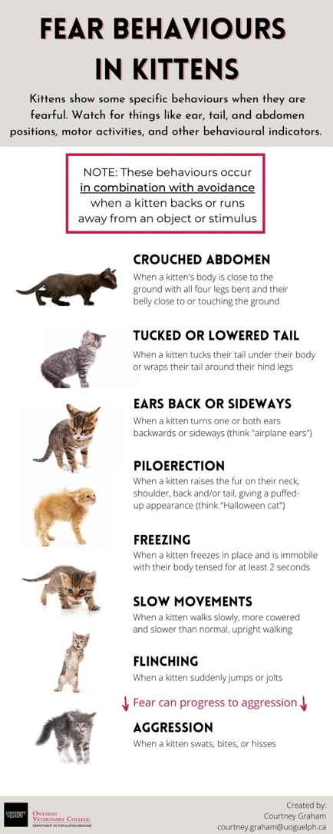

- Please fill in the following details for each kitten.
Note: Fear behaviours* include showing avoidance, hiding, ears facing backwards or sideways, piloerection (puffing up of the fur), tucked or lowered tail, lowered or crouched abdomen, hissing.
(Kitten names prompted from earlier question; dropdown lists after each kitten for the following details: Sex (M/F); Current age (select from 7, 8, or 9 weeks); Estimated age when you first got kitten (select from Less than 1 week to 9 weeks); Coat colour (select from Tabby (brown, grey, orange); Solid black; Solid grey; Solid white; Bi-colour (e.g., black with white, white with black, grey with white, white with grey); Tri-colour (calico, tortoiseshell); Other); Was this kitten fearful* at intake into foster care? (select from Yes/No))
- When a new or unfamiliar person is introduced to your kittens, how does each kitten typically respond? Please select the answer that generally best describes each kitten.
(Kitten names prompted from earlier question; Select any from: Kitten approaches person and is friendly (e.g., rubs, enjoys petting); Kitten approaches OR does not approach person and is NOT friendly (e.g., bites, swats, hisses); Kitten is indifferent (e.g., neither approaches nor moves away, and does not pay attention); Kitten stays hidden or hides; N/A (due to COVID-19, or other))

- When a new or unfamiliar person is introduced to your kittens, do the kittens show any of the following behaviours. Please select all that apply for each kitten.
(Kitten names prompted from earlier question; Select any from: Avoidance (kitten backs or runs away from object); Freezing (kitten is immobile with body tensed for at least 2 sec); Crouching (kitten holds body close to ground with all 4 legs bent and belly touching the ground); Ears back (kitten turns one or both ears backwards or sideways); Piloerection (kitten raises fur on nape of neck/shoulder/back/tail, giving a puffed-up appearance); Aggression (e.g., swatting, hissing); Excessive grooming; Excessive vocalizations)
- When a new or unfamiliar object is introduced to your kittens, how does each kitten typically respond? Please select the answer that generally best describes each kitten.
(Kitten names prompted from earlier question; Select any from: Kitten approaches person and is friendly (e.g., rubs, enjoys petting); Kitten approaches OR does not approach person and is NOT friendly (e.g., bites, swats, hisses); Kitten is indifferent (e.g., neither approaches nor moves away, and does not pay attention); Kitten stays hidden or hides; N/A (due to COVID-19, or other))
- When a new or unfamiliar object is introduced to your kittens, do the kittens show any of the following behaviours. Please select all that apply for each kitten.
(Kitten names prompted from earlier question; Select any from: Avoidance (kitten backs or runs away from object); Freezing (kitten is immobile with body tensed for at least 2 sec); Crouching (kitten holds body close to ground with all 4 legs bent and belly touching the ground); Ears back (kitten turns one or both ears backwards or sideways); Piloerection (kitten raises fur on nape of neck/shoulder/back/tail, giving a puffed-up appearance); Aggression (e.g., swatting, hissing); Excessive grooming; Excessive vocalizations)
- What headline and key words would you use to describe each kitten if you were writing their adoption ad (e.g., personality traits, physical descriptions, etc.)?
[Note: Descriptions submitted will not be used for adoption purposes.]
(Kitten names prompted from earlier question; text boxes for each kitten)

End of Survey (prompt to prize draw)
Thank you for participating in our study!
Please enter your email address for a chance to be included in a draw for 1 of 3 CAD$100 prize packs comprising of CAD$25 of kitten supplies for you and a CAD$75 donation to your affiliated shelter in your name (or anonymous if preferred). Chances of winning are approximately 1 in 25. If you provide this information, it will be collected and stored separately from survey responses. Selected winners will be notified by email and will be given one week to respond. All email addresses will be destroyed after the prize draw is complete and winners confirmed.
[Text box for email address]

