Supplamentary material

Supplamentary Table 1: Patient’s description of events associated with guilt episodes

No. | Patient’s description
1 | "Maybe I’ve offended someone […] something that happened in class […] maybe fighting with someone"
2 | "I didn’t like the person I talked to […] I didn’t really listen"
3 | "I was taking a photograph of a large group, and felt I am at a place I am not supposed to be"
4 | "After I argued with my mother"
5 | "I was supposed to meet somebody but did not"
6 | "I said goodbye to my brother before a long journey"
7 | "I felt I was getting punsihed for lying, usually in the context of "white lies""

Supplamentary Table 2: Guilt and detachment responses elicited by electrical brain stimulation

Stimulation Target Site | Current (Am) | Patient Resopnse
Electrodes RMH 1 & 2 (right hippocampus)
 | 2 | “Distress, nausea, the distress causes the nausea”
 | 4 | “Nausea”
 | 6 | “I felt distress and nausea”
 | 8 | “Distress, guilt, nausea”
 | 10 | “Distress, guilt, much stronger”
Electrodes RMH 2 & 3 (lateral to right hippocampus)
 | 2 | “Beginning of detachment, without other sensations”
 | 4 | “Beginning of distress, I begin to detach”
 | 6 | “Detachment without other feelings”; “I feel I’m not here”
 | 8 | “I feel I’m not here, suddenly there’s a world, and there’s me inside something closed, like an aquarium, and I’m looking out”
 | 10 | “Feeling of detachment, nausea, distress”
Electrodes RMH 3 & 4 (lateral to right hippocampus)
 | 8 | “Detachment”
 | 10 | “Detachment”
Electrodes RA 1 & 2 (right amygdala)
 | 4 | “I begin to feel separated, I suddenly feel left out, and it makes me nauseated”
 | 8 | “Detachment, distress, a light nausea”
 | 10 | “Really strong distress, guilt, nausea, long detachment”
Electrodes RA 2 & 3 (white matter lateral to right amygdala)
 | 8 | “Regular detachment”
 | 10 | “It’s like I can’t talk, something separates me from the world”; “Suddenly I feel detached, there’s a difference between me and the surroundings, it’s not natural for me to speak”
Electrodes RA 3 & 4 (white matter lateral to right amygdala)
 | 6 | “It’s not natural for me to speak, it was better for me to be silent, I didn’t feel detached”
 | 8 | “It’s like I’m not here”; “Separated”
 | 10 | “It’s not related to speech, it’s more related to the surrounding, the situation is strange”; “It’s like I’m not supposed to be here”
Electrodes RA 4 & 5 (white matter lateral to right amygdala)
 | 4 | “I’m a single unit, and you are you”; “I feel separated, seeing people makes me feel this way more than when I’m alone”
 | 6 | “Maybe a bit of detachment”
 | 8 | “I feel something is separated”; “Seeing things makes me nauseated”
 | 10 | “There’s no difference from the feeling of before, both are stronger”
Electrodes RA 5&6 (white matter near right amygdala)
 | 6 | “I think I feel a light detachment, without other things”
 | 10 | “Just detachment, without guilt nor distress, there’s a separation between us”

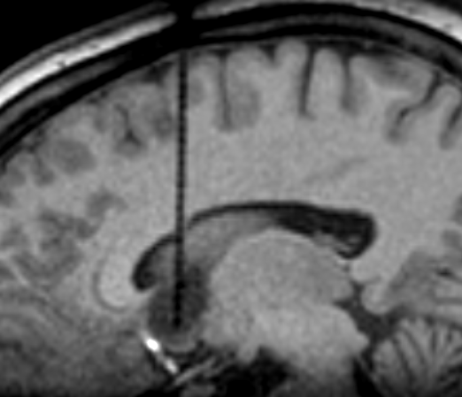

Supplamentary Figure 1. Laser probe in tumor during laser ablation.
Sagittal MRI obtained during the first laser ablation surgery showing laser optical fiber inserted into the tumor (white arrow).

