Table S1. Pearson product moment partial correlations between creative achievement, personality and intelligence, adjusting for age and sex.

 | ∑CAQ | ∑ART | ∑SCI | BFI_A | BFI_C | BFI_E | BFI_N | BFI_O
∑ART | .90
∑SCI | .61 | .20
BFI_A | .04^{ns} | .05 | .00^{ns}
BFI_C | −.05 | −.07 | .00^{ns} | .30
BFI_E | .09 | .11 | .01^{ns} | .29 | .30
BFI_N | .02^{ns} | .03^{ns} | −.03^{ns} | −.44 | −.42 | −.39
BFI_O | .50 | .48 | .25 | .09 | .02^{ns} | .26 | −.05
WMT | .24 | .13 | .31 | .02^{ns} | −.02^{ns} | −.06 | −.06 | .11
Values are averages based on a split-half analysis for twin1 and twin2. Unless specified, correlations were significant at p < .05, two-tailed, in both samples. ∑ART = sum of artistic creative achievements, ∑CAQ = total sum of creative achievements, ∑SCI = sum of scientific achievements, BFI_A = agreeableness, BFI_C = conscientiousness, BFI_E = extraversion, BFI_N = neuroticism, BFI_O = openness, WMT = Wiener Matrizen Test (intelligence)
^{ns} Non-significant.
Table S2. Commonality analysis and explained variance of creative achievement regressed on extraversion, openness, intelligence, age and sex.
 | ∑ART | ∑SCI
Unique to BFI_O | 20.43 | 4.78
Unique to BFI_E | 0.02 | 0.13
Unique to WMT | 0.59 | 7.02
Unique to AGE | 0.15 | 0.19
Unique to SEX | 2.56 | 4.52
Common to BFI_O, and BFI_E | 1.22 | -0.07
Common to BFI_O, and WMT | 1.19 | 1.67
Common to BFI_E, and WMT | 0.02 | 0.20
Common to BFI_O, and AGE | 0.02 | 0.01
Common to BFI_E, and AGE | 0.01 | 0.02
Common to WMT, and AGE | 0.14 | 0.65
Common to BFI_O, and SEX | -0.30 | 0.21
Common to BFI_E, and SEX | -0.01 | 0.16
Common to WMT, and SEX | -0.25 | 1.49
Common to AGE, and SEX | 0.02 | -0.02
Common to BFI_O, BFI_E, and WMT | -0.14 | -0.23
Common to BFI_O, BFI_E, and AGE | -0.07 | -0.04
Common to BFI_O, WMT, and AGE | 0.13 | 0.12
Common to BFI_E, WMT, and AGE | 0.01 | 0.07
Common to BFI_O, BFI_E, and SEX | 0.29 | -0.20
Common to BFI_O, WMT, and SEX | -0.19 | 0.27
Common to BFI_E, WMT, and SEX | -0.02 | 0.16
Common to BFI_O, AGE, and SEX | 0.00 | 0.00
Common to BFI_E, AGE, and SEX | -0.01 | 0.01
Common to WMT, AGE, and SEX | -0.03 | 0.07
Common to BFI_O, BFI_E, WMT, and AGE | -0.06 | -0.07
Common to BFI_O, BFI_E, WMT, and SEX | -0.01 | -0.10
Common to BFI_O, BFI_E, AGE, and SEX | 0.00 | 0.00
Common to BFI_O, WMT, AGE, and SEX | 0.00 | 0.01
Common to BFI_E, WMT, AGE, and SEX | -0.01 | 0.03
Common to BFI_O, BFI_E, WMT, AGE, and SEX | 0.00 | -0.01
Total | 25.69 | 21.04

∑ART = sum of artistic creative achievements, ∑SCI = sum of scientific achievements, BFI_E = extraversion, BFI_O = openness, WMT = Wiener Matrizen Test (intelligence)

Table S3. Artistic creative achievement (MAX_ART) regressed on openness to experience and intelligence.
 | β | SE | t
BFI_O | 1.20 | 0.07 | 16.55
WMT | 16.90 | 1.95 | 8.66
SEX(f) | 0.12 | 0.08 | 1.54^{ns}
BFI_O:SEX(f) | −0.35 | 0.08 | −4.21
‘:’ represents an interaction, BFI_O = openness to experience, SEX(f) = being female, WMT = Wiener Matrizen Test (intelligence). Values are averages based on a split-half analysis for twin1 and twin2. Unless specified, only estimates significant at p < 0.05, two-tailed, in both samples, are reported with the exception of non-significant main effects of significant interactions.
^{ns} non-significant

Table S4. Scientific creative achievement regressed on openness to experience and intelligence.
 | β | SE | t
AGE | −0.19 | 0.05 | −4.00
BFI_O | 0.91 | 0.05 | 17.29
SEX(f) | −0.48 | 0.09 | −5.18
WMT | 29.61 | 2.78 | 10.65
BFI_O = openness to experience, SEX(f) = being female, WMT = Wiener Matrizen Test (intelligence). Values are averages based on a split-half analysis for twin1 and twin2. Only estimates significant at p < 0.05, two-tailed, in both samples, are reported.

Table S5. Frequency table of MZ and DZ twins (of complete pairs) by the level of MAX_ART and MAX_SCI.

 | MAX_ART |  | MAX_SCI
Level | MZ | DZ | MZ | DZ
1 | 344 | 190 | 344 | 190
2 | 209 | 115 | 173 | 114
3 | 661 | 383 | 214 | 104
4 | 241 | 138 | 157 | 69
Total | 1455 | 826 | 888 | 477

MAX_ART = artistic creative achievement, MAX_SCI = scientific creative achievement, MZ = monozygotic twins, DZ = dizygotic twins

Table S6. Univariate model fitting results for creative achievement (artistic/scientific), openness to experience and intelligence, corrected for age and sex.

 | model | AIC | −2LL | df | ∆−2LL | ∆−df | p | A | D | G | C | E
MAX_ART | ACE | 1129.27 | 5753.27 | 2312 |  |  |  | 0.37 |  |  | 0.32 | 0.32
 | AE | 1133.14 | 5759.14 | 2313 | 5.87 | 1 | 0.015 | 0.70 |  |  |  | 0.30
 | CE | 1136.92 | 5762.92 | 2313 | 9.65 | 1 | 0.002 |  |  |  | 0.63 | 0.37
 | E | 1389.99 | 6017.99 | 2314 | 258.85 | 1 | < 0.001 |  |  |  |  | 1.00
MAX_SCI | ADE | 919.46 | 3997.46 | 1539 |  |  |  | 0.68^{ns} | 0.00^{ns} |  |  | 0.32
 | AE | 917.46 | 3997.46 | 1540 | 0.00 | 1 | 1.000 | 0.68 |  |  |  | 0.32
 | DE | 920.64 | 4000.64 | 1540 | 3.18 | 1 | 0.075 |  | 0.69 |  |  | 0.31
 | E | 1052.11 | 4134.11 | 1541 | 136.65 | 1 | < 0.001 |  |  |  |  | 1.00
 | GE | 919.46 | 3997.46 | 1539 |  |  |  |  |  | 0.68 |  | 0.32
BFI_O | ADE | 2798.74 | 10350.74 | 3776 |  |  |  | 0.54^{ns} | 0.03^{ns} |  |  | 0.43
 | AE | 2796.79 | 10350.79 | 3777 | 0.05 | 1 | 0.818 | 0.57 |  |  |  | 0.43
 | DE | 2809.81 | 10363.81 | 3777 | 13.07 | 1 | < 0.001 |  | 0.58 |  |  | 0.42
 | E | 3263.83 | 10819.83 | 3778 | 469.04 | 1 | < 0.001 |  |  |  |  | 1.00
 | GE | 2798.74 | 10350.74 | 3776 |  |  |  |  |  | 0.57 |  | 0.43
WMT | ACE | 2225.55 | 8995.55 | 3385 |  |  |  | 0.45 |  |  | 0.13 | 0.42
 | AE | 2226.44 | 8998.44 | 3386 | 2.89 | 1 | 0.089 | 0.59 |  |  |  | 0.41
 | CE | 2259.04 | 9031.04 | 3386 | 35.49 | 1 | < 0.001 |  |  |  | 0.50 | 0.50
 | E | 2659.97 | 9433.97 | 3387 | 435.53 | 1 | < 0.001 |  |  |  |  | 1.00
The most parsimonious models are shown in bold face. AE and CE/DE models were compared to the ACE/ADE models. The E models were compared to the AE models. ADE and GE models are not nested and thus cannot be compared. −2LL = log-likelihood ratio, A = additive genetic, AIC = Akaike information criterion, BFI_O = openness, C = shared environmental, D = dominant genetic, df = degrees of freedom, E = non-shared environmental, G = genetic (A+D), MAX_ART = artistic creative achievement, MAX_SCI = scientific creative achievement, WMT = intelligence.

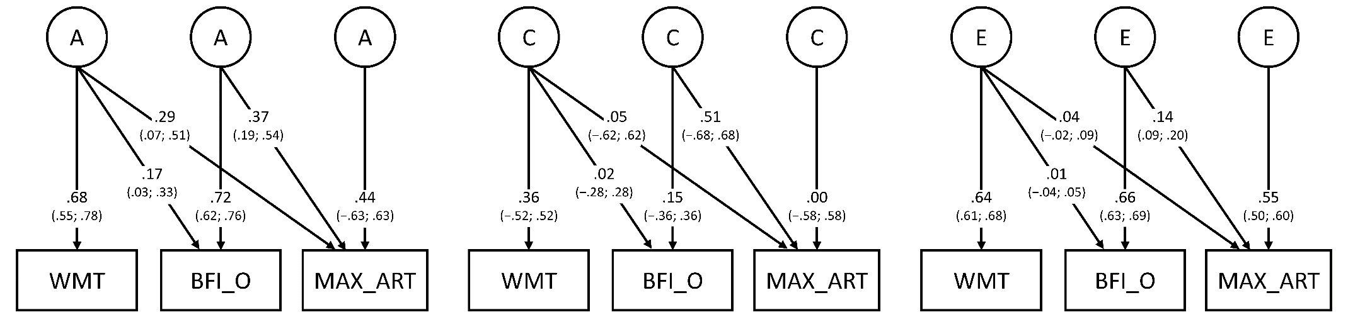
Figure S1. Trivariate ACE Cholesky decomposition for artistic creative achievement (MAX_ART), openness to experience (BFI_O) and intelligence (WMT), for additive genetic (A), shared environmental (C), and non-shared environmental influences (E), corrected for age and sex. Numerical values represent standardized path coefficients with confidence intervals in parenthesis.

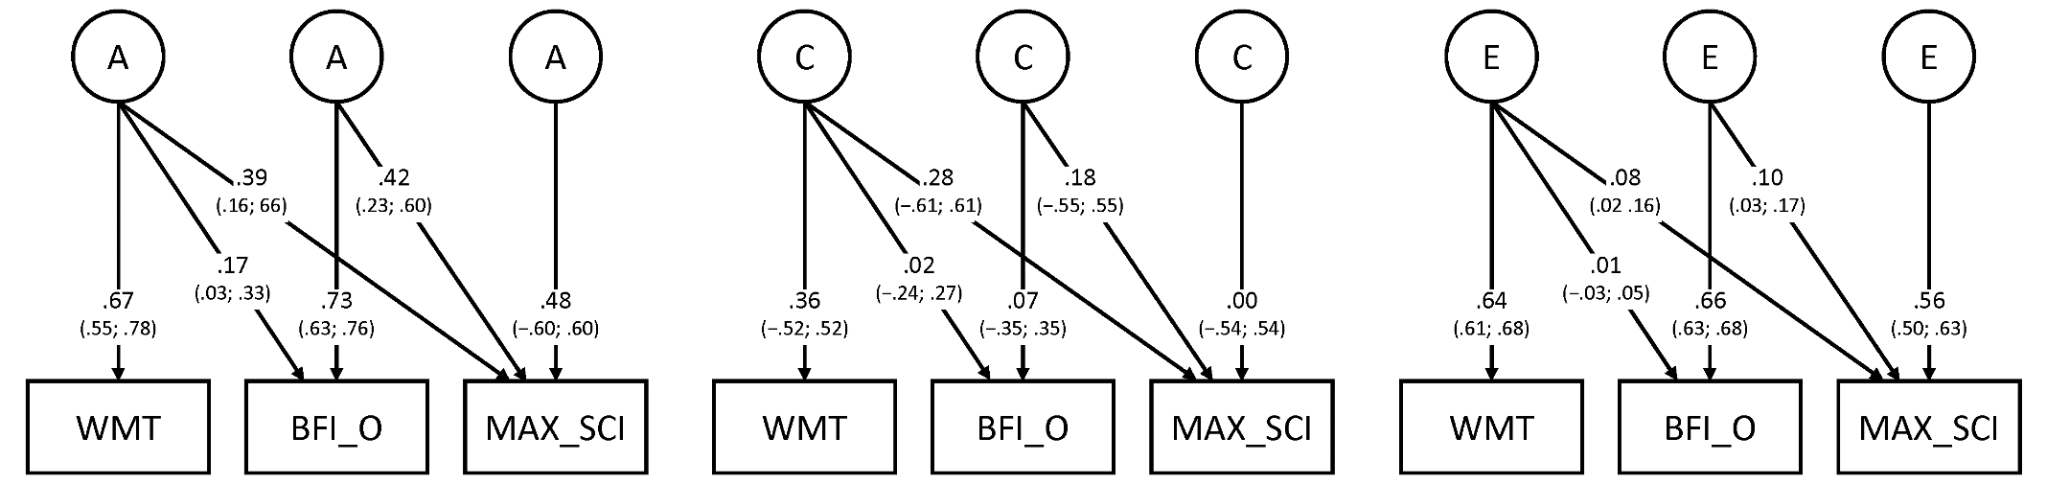
Figure S2. Trivariate ACE Cholesky decomposition for scientific creative achievement (MAX_SCI), openness to experience (BFI_O) and intelligence (WMT), for additive genetic (A), shared environmental (C), and non-shared environmental influences (E), corrected for age and sex. Numerical values represent standardized path coefficients with confidence intervals in parenthesis.

