Supplementary Material for

Vultures as an overlooked model in cognitive ecology

Thijs van Overveld¹, Daniel Sol², Guillermo Blanco^{3,} Antoni Margalida^{4,5}, Manuel de la Riva¹, José Antonio Donázar¹

¹ Department of Conservation Biology, Estación Biológica de Doñana (CSIC), Sevilla, Spain
² CSIC-CREAF, Cerdanyola del Vallès, Catalonia E-08193, Spain
³ Department of Evolutionary Ecology, Museo Nacional de Ciencias Naturales (CSIC), Madrid, Spain
⁴ Institute for Game and Wildlife Research, IREC (CSIC-UCLM-JCCM), Ciudad Real, Spain
⁵ Division of Conservation Biology, Institute of Ecology and Evolution, University of Bern, Switzerland.

T. van Overveld ()
Department of Conservation Biology, Estación Biológica de Doñana (CSIC), Américo Vespucio s/n, E-41092, Sevilla, Spain
Email: mathijs.van.overveld@gmail.com
Phone:+34954466700

Videos

Video 1: Griffon Vulture feeding at night. (Credits O. Frías and G. Blanco)
http://dx.doi.org/10.6084/m9.figshare.14330261

Video 2: Egyptian vultures ritualized dominance display. (Credits: T. van Overveld)
http://dx.doi.org/10.6084/m9.figshare.6201101

Video 3: Escalated fight between female Egyptian vultures (Credits: T. Mulet) http://dx.doi.org/10.6084/m9.figshare.9248843

Video 4: Egyptian vultures allopreening between an unpaired male and female. (Credits: T. van Overveld)
http://dx.doi.org/10.6084/m9.figshare.6201125

Video 5: Egyptian Vulture parental cooperation. (Credits T. van Overveld) http://dx.doi.org/10.6084/m9.figshare.12111621

Figures

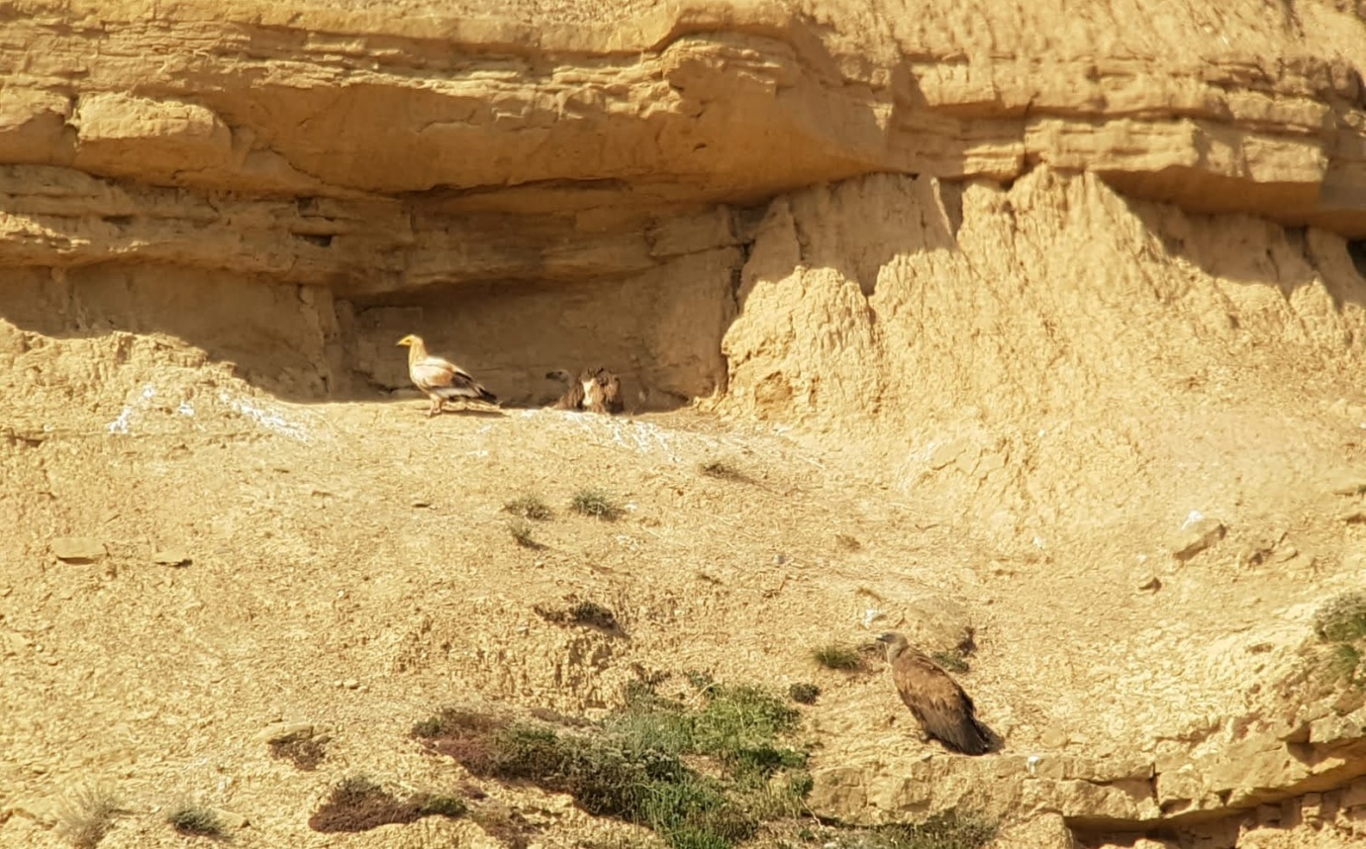
Fig. S1 Egyptian vulture at a nest of a Griffon vulture trying to find/steal food. Credits: Alejandro Urmeneta.
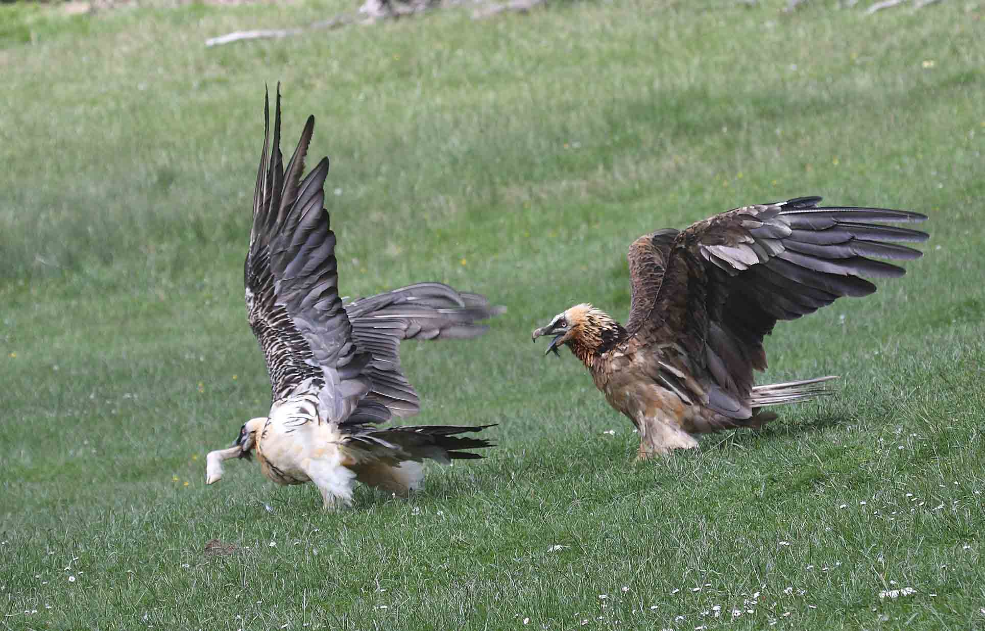
Fig. S2. Bone-stealing in Bearded vulture. Credits: José Antonio Sesé.

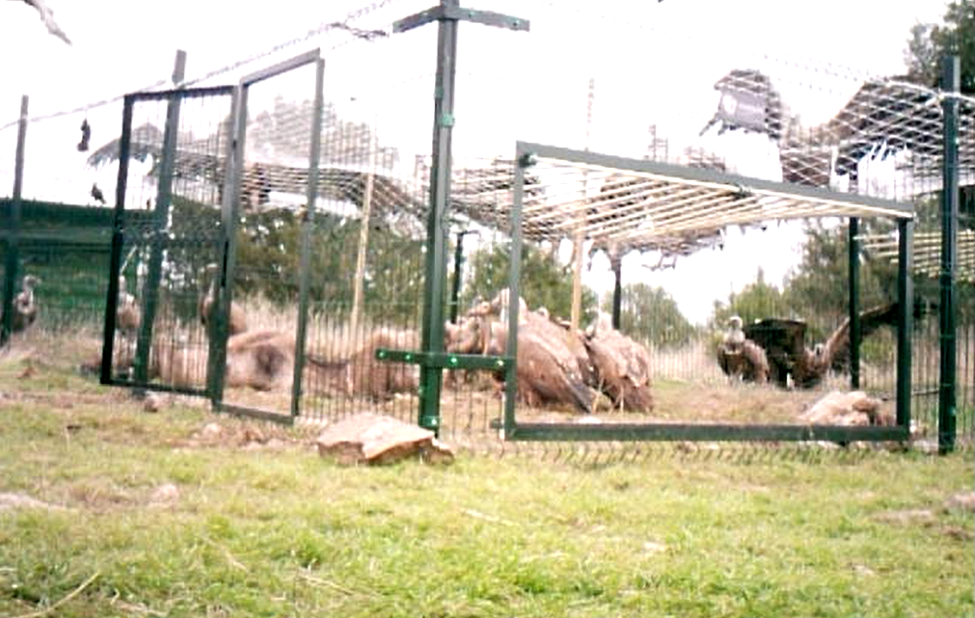
Fig. S3. Metal cage to trap Griffon vultures. Video still: Guillermo Blanco.

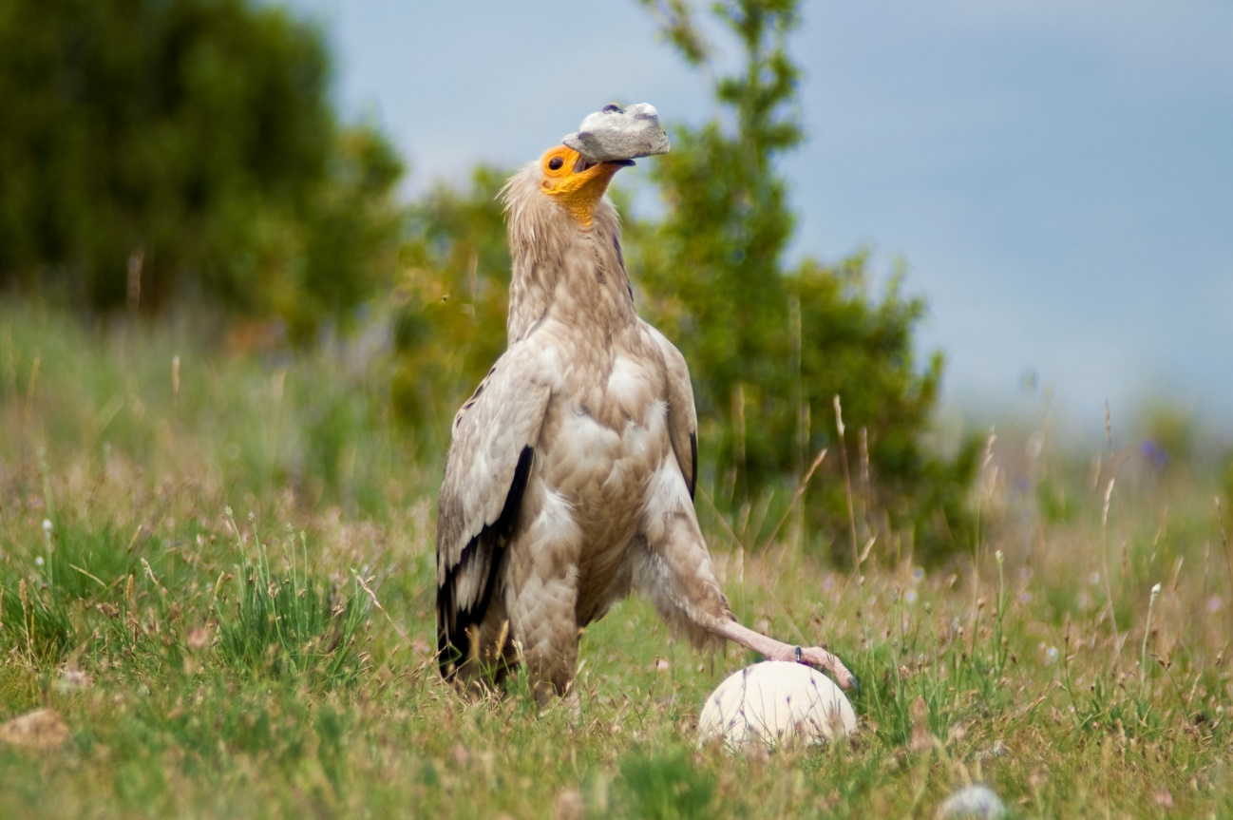
Fig S4. Stone throwing by an Egyptian vulture to crack open eggs. Note the bird holding the ostrich egg, presumably to avoid it slipping away. Credits: Rafa Pelayo.
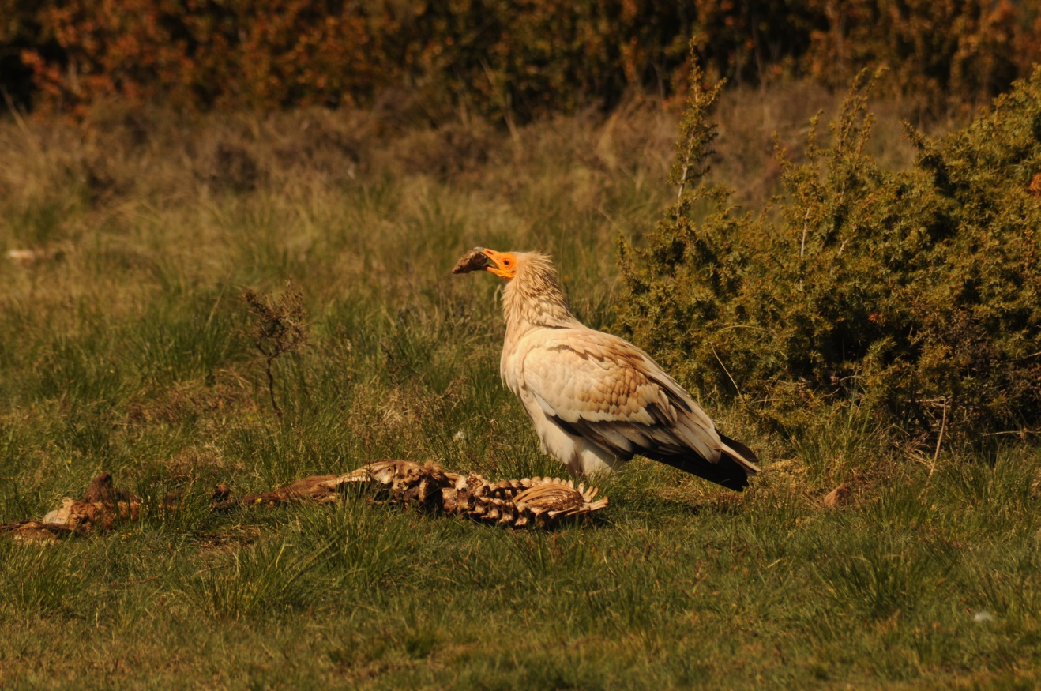
Figure S5. Egyptian Vulture throwing a stone at a carcass, possibly to break off a piece of bone/meat. Credits: Maria José Monge.
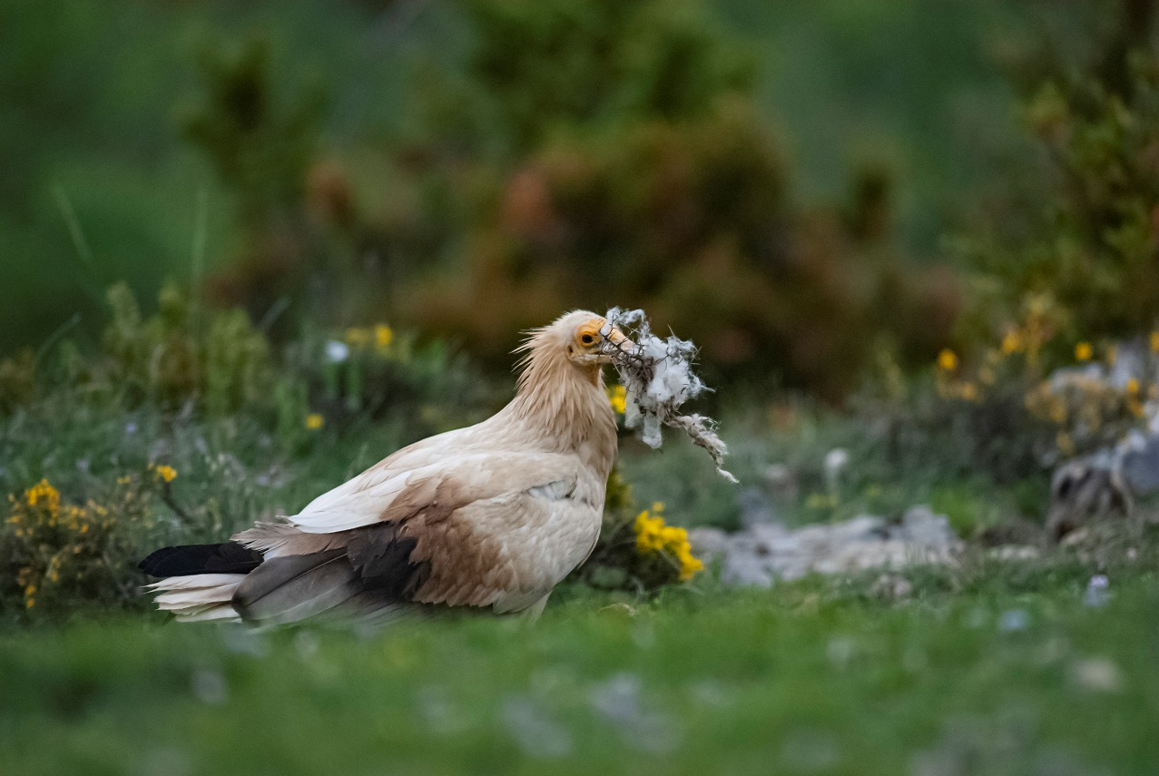
Figure S6. Egyptian vultures collecting a twig of Spanish broom (Genista scorpius) with wool from sheep attached to it (credits: Rafa Pelayo).

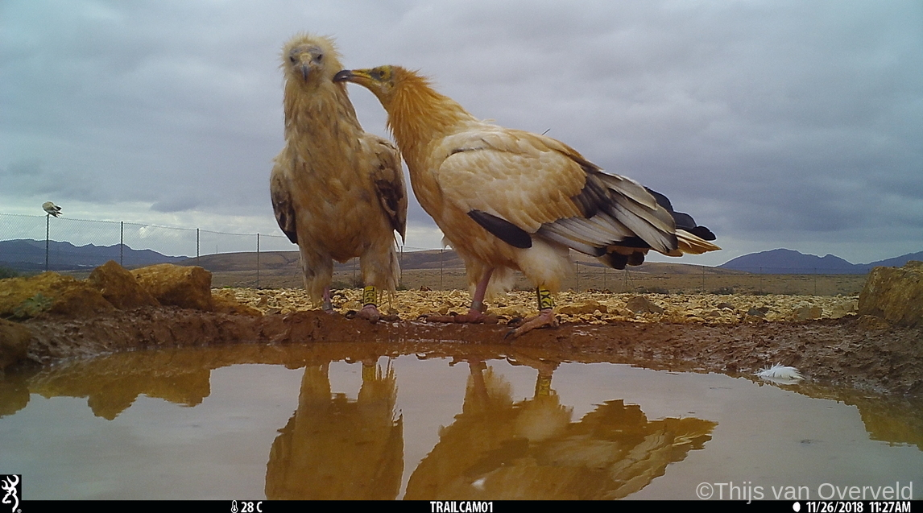
Fig. S7. Brief contact between a paired adult female (right) and an unrelated immature female (left). Credits: Thijs van Overveld.

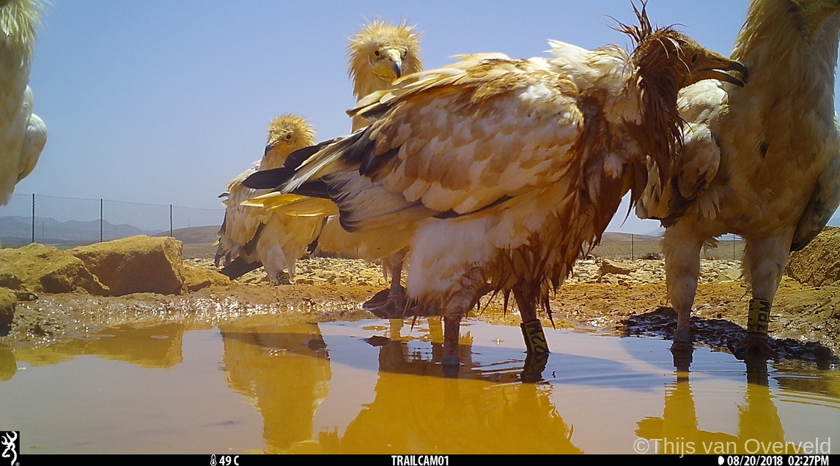
Fig. S8. During bathing, individuals sometimes may suddenly stop their activities and engage in allopreenig with a new visitor. Credits: Thijs van Overveld.

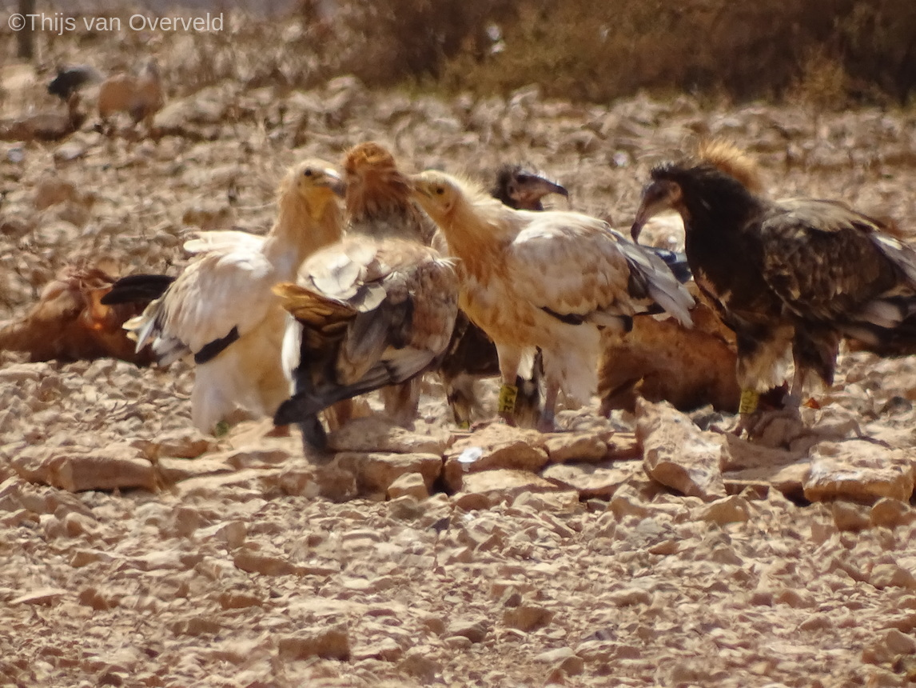
Fig. S9. Elaborate allopreening between two females at a drinking bowl in the presence of other individuals. Credits: Thijs van Overveld.
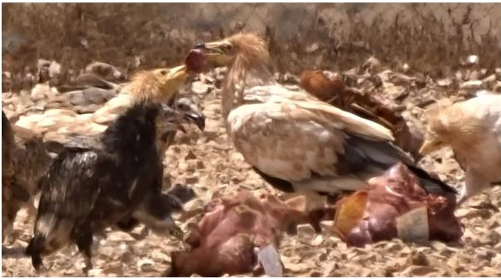
Figure S10. Pair at the feeding station in August 2016, with the female (right) handing over a piece of meat to the male (left). The female walked around with this piece of meat for more than 10 minutes until she detected the male. Video still: Thijs van Overveld.

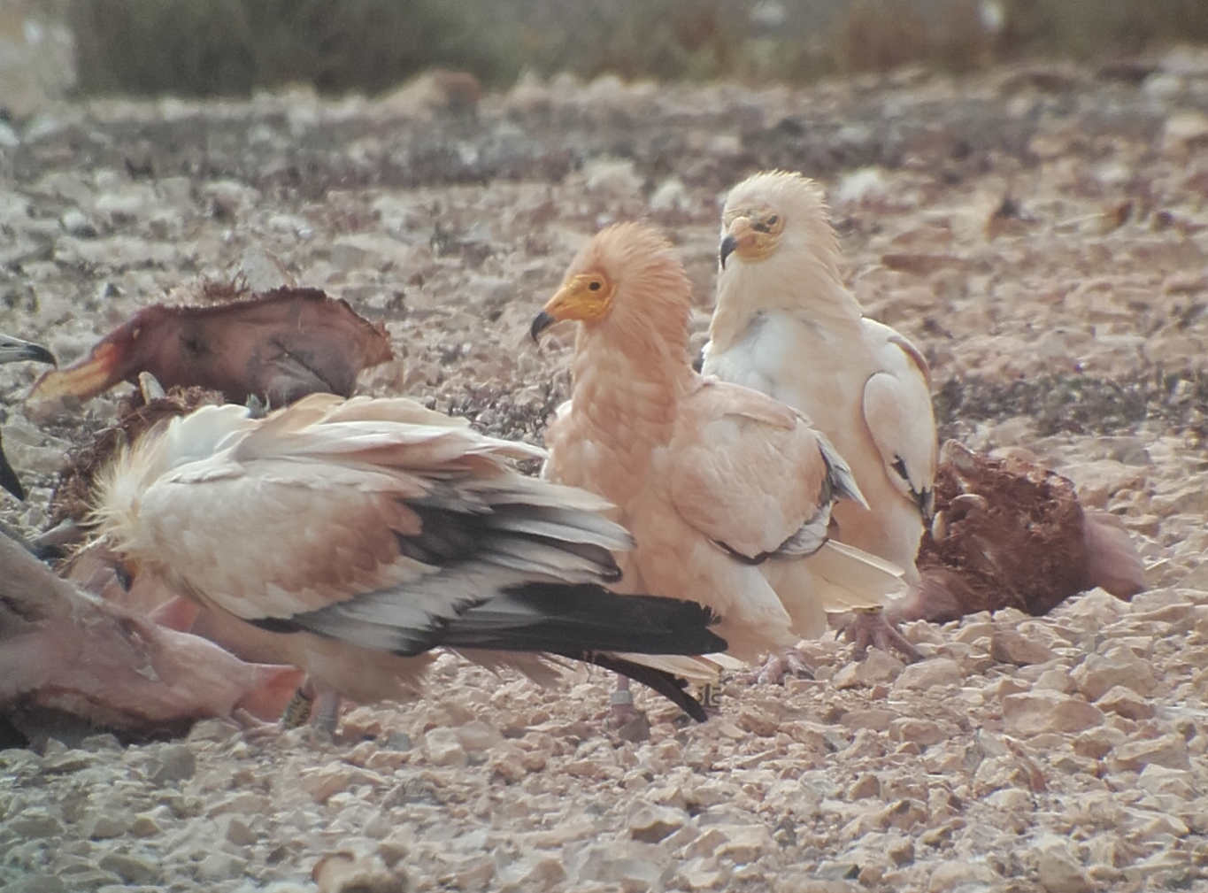
Figure S11. Alpha male (middle bird) from a polyndrous trio mate-guarding the female (left)). During the fertile period (end of Februaryy/start of March) this male was standing next to her most of the time. Credits: Thijs van Overveld. 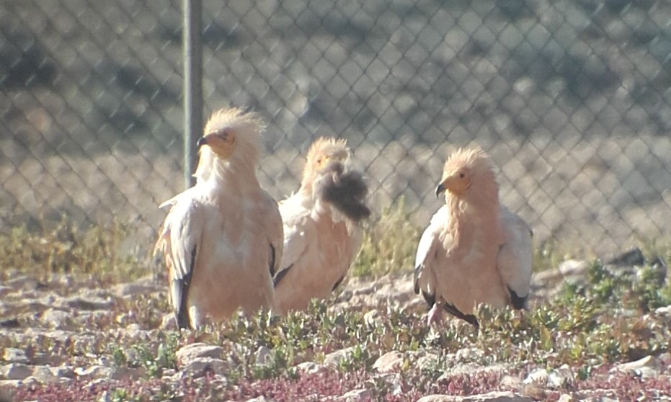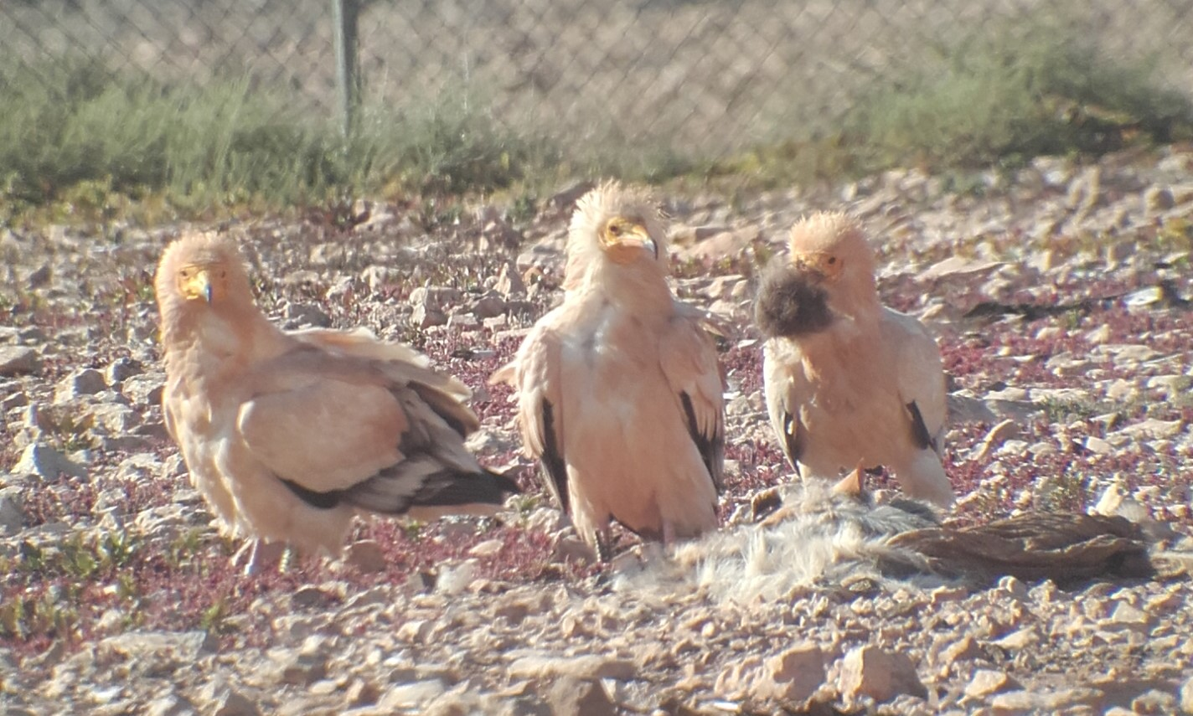
Fig. S12. The beta male of a polyandrous trio with a beak full of nesting material trying to impress the female (top: left ; bottom: middle), while she is mate-guarded by the alpha male (top: right, bottom: left). Credits:Thijs van Overveld.

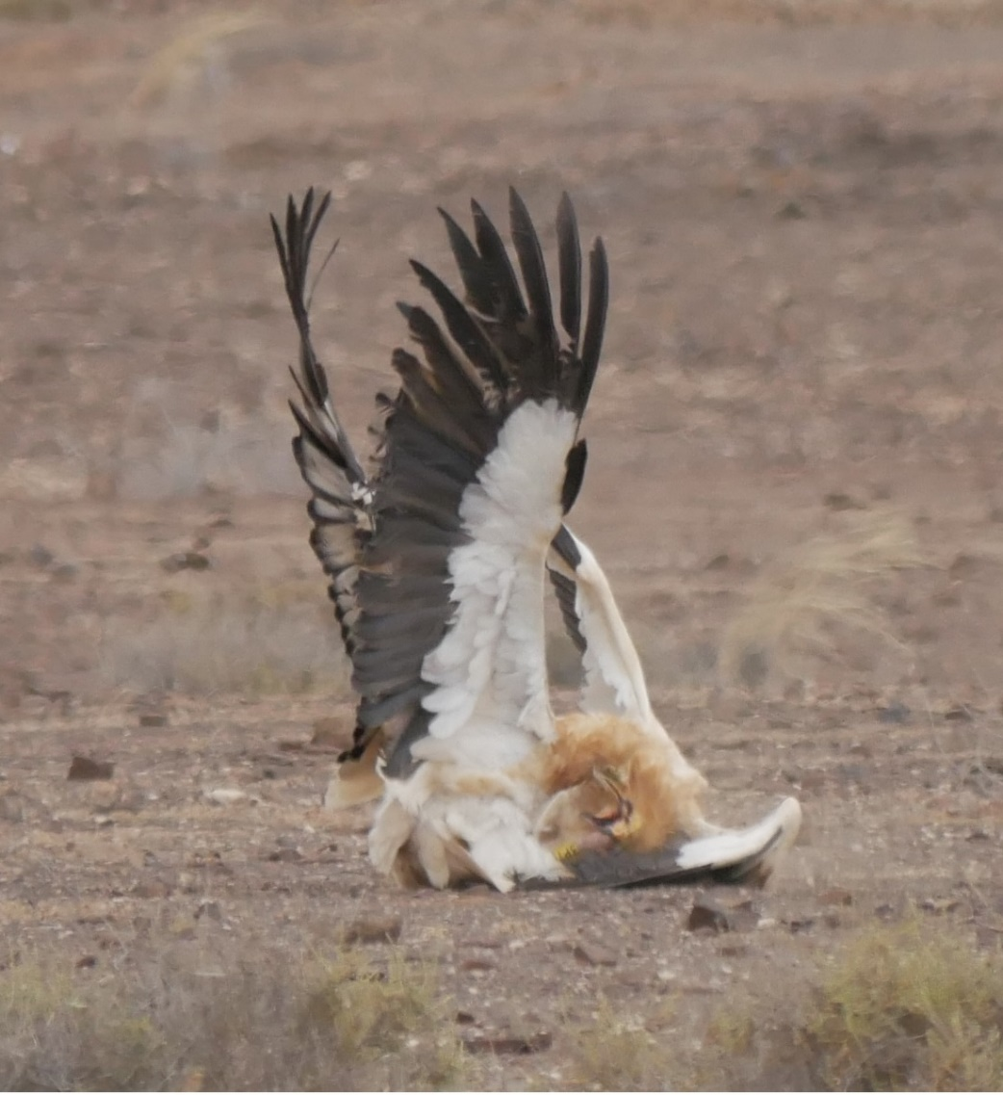
Figure S13. Territoral fight between two females during the pre egg-laying period (March 2019). Even though females can be very aggressive they sometimes tolerate an additional female in their territory. Credits: Toni Mulet.
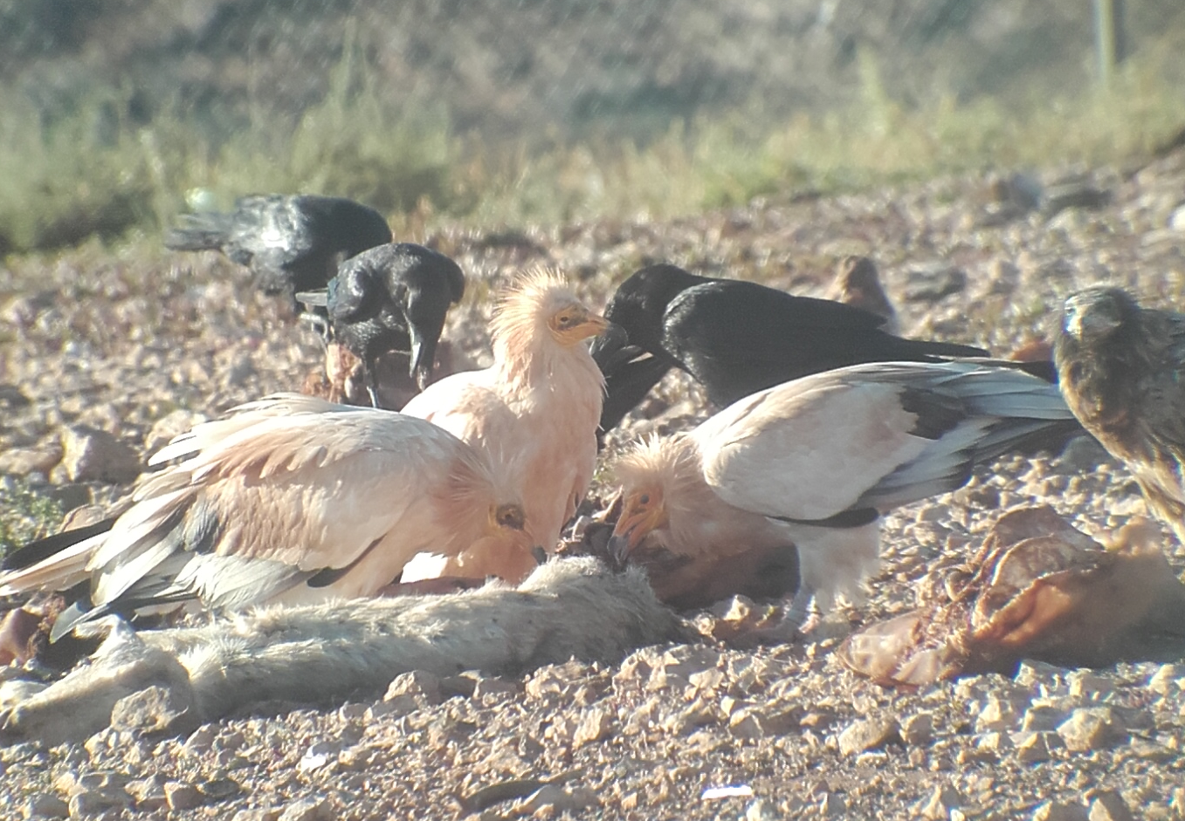
Figure S14. Members of a long-term polygenous trio feeding together at a carcass at the central feeding station (male marked as 1TJ (right), alpha female marked as 1H4 (left), beta female marked as 22J (middle). This trio is together for 10 years (2011-2020). Credits: Thijs van Overveld.
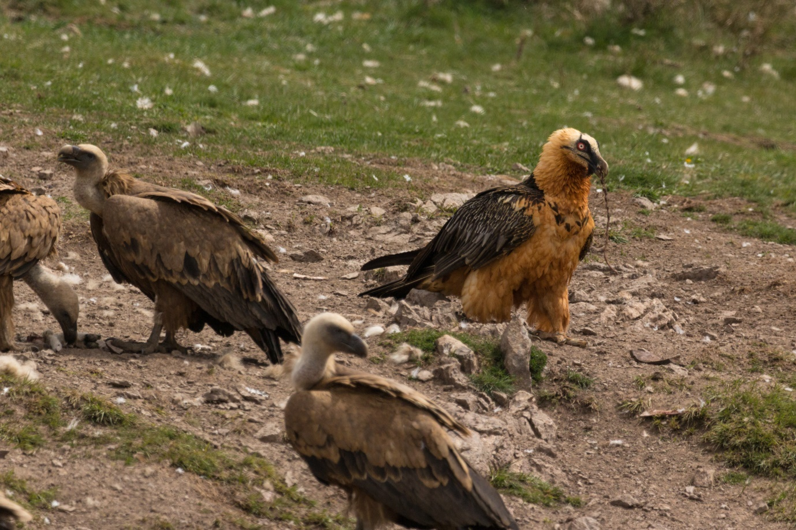
Fig. S15. A very red painted Bearded Vulture. Credits: P. Oliva.
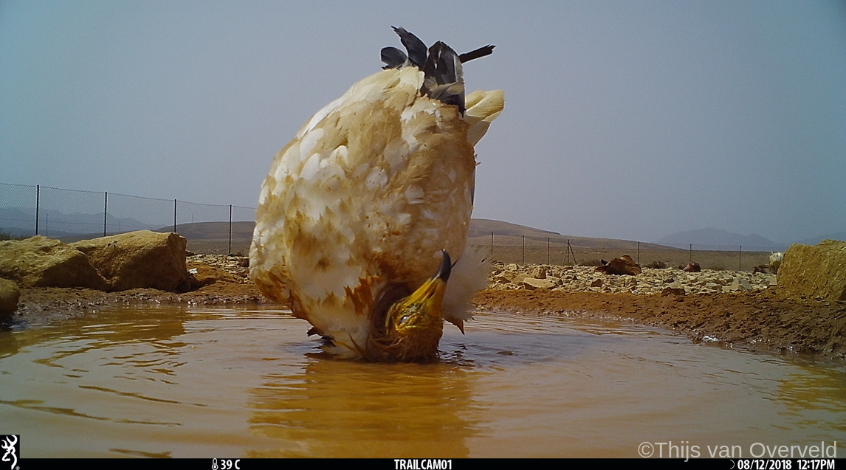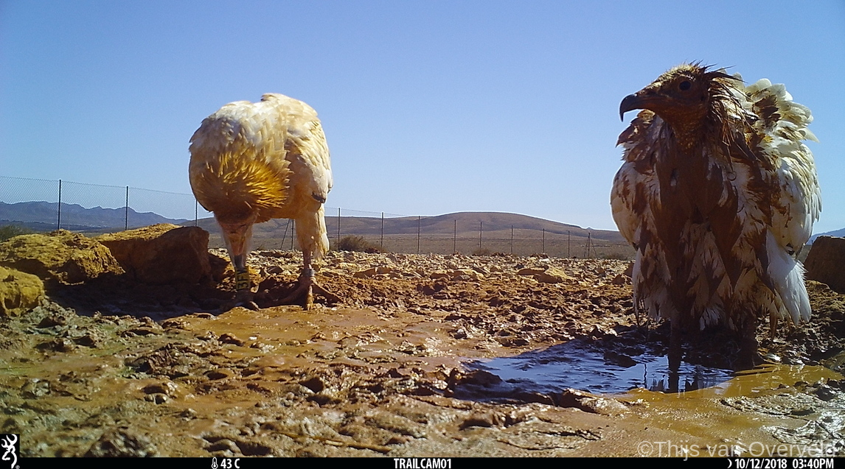
Fig. S16. Canarian Egyptian Vultures taking mud baths. Credits: Thijs van Overveld.

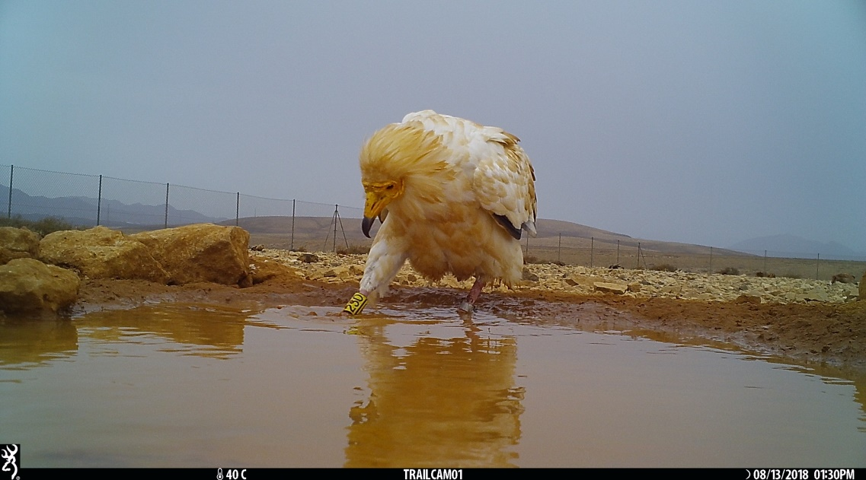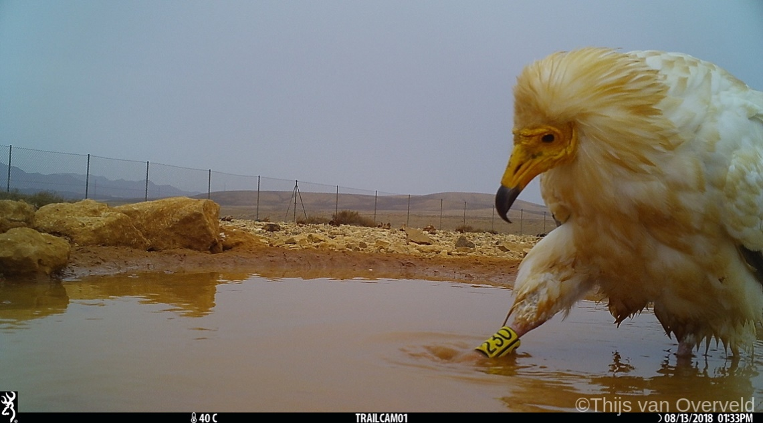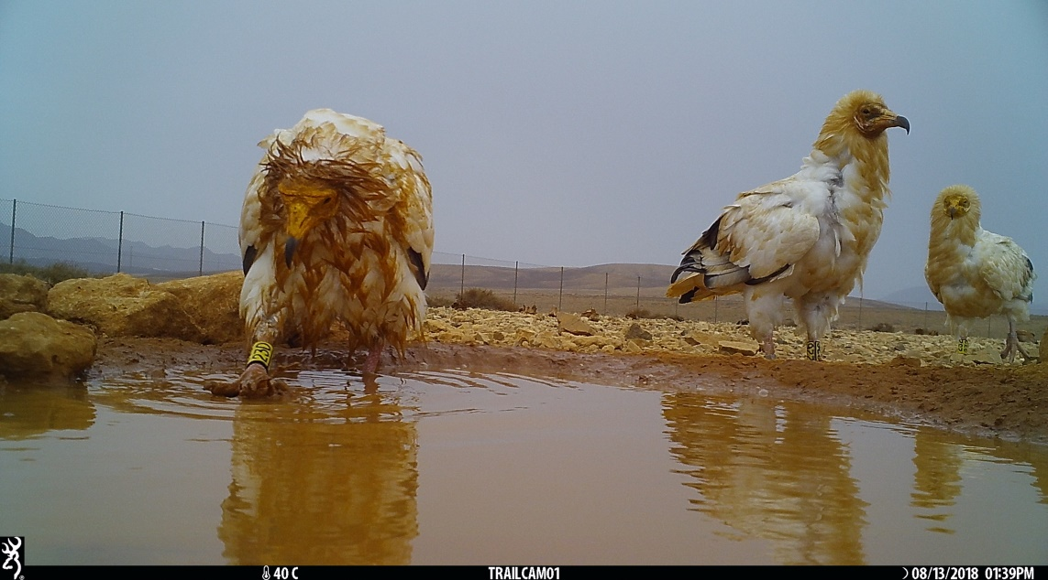
Fig. S17 An adult male Canarian Egyptian Vulture scratching his feet in a muddy pool. Credits:Thijs van Overveld.

